**VMWare**

VMware, Inc. is a U.S. software company that provides cloud and virtualization software and services, and was the first to successfully virtualize the x86 architecture. Founded in 1998, VMware is based in Palo Alto, California. In 2004 it was acquired by and became a subsidiary of EMC Corporation, then on August 14, 2007, EMC sold 15% of the company in a New York Stock Exchange IPO. The company trades under the symbol VMW

**What is VMWare?**

The hardware of today, regardless of processor count or core count, was designed to run a single operating system. This leaves most machines vastly underutilized. VMware virtualization lets you run multiple virtual machines on a single physical machine, with each virtual machine sharing the resources of that one physical computer across multiple environments. Different virtual machines can run different operating systems and multiple applications on the same physical computer. VMware is an operating system that sits directly on the hardware and is the interface between the hardware and the various operating systems. It expands the hardware, from the user’s point of view, to many different independent servers all with their own processors and memory. These virtual servers cannot be distinguished from physical servers by the end users.

**How Does VMware work?**

VMware works by loading a small, efficient operating system, or **hypervisor** directly on the host hardware. The VMware hypervisor has a small footprint and is extremely efficient, with a very small (1%) overhead. Device drivers for nearly all major brand devices are available from VMware. These are loaded during the configuration process.  
  
The client operating systems, such as Microsoft® Server 2008, Linux varieties, etc. are then set up as virtual machines, working directly with the VMware layer rather than with the actual hardware. This allows replacement of hardware to be very simple. If the hardware is replaced, VMware is reconfigured for the new hardware, and the virtual guest operating systems see no change whatsoever and are immediately able to boot and operate.

**How Resources Allocated? Are Separate Cores Needed for Each O/S?**

***Processors***To explain how processor resources are allocated, first of all one need to understand how VMware treats processors. As an example, consider a server, with 128GB of memory and Dual 8-Core 2.7Ghz Intel® Xeon™ processors. This would be presented to VMware as a processor pool at ( 16 * 2.7) = 43Ghz. During the configuration process for virtual operating systems guests, each VM can be assigned a portion of that available processor pool. This assignment is most often left to VMware to perform dynamically during operation.

***Memory***Memory usage can also either be set during configuration or left to VMware to configure dynamically. You may wish to limit memory usage on some servers, such as exchange, that will attempt to consume as much memory as is available.  
  
**Data Storage and Drives**   
VMware is capable of using a drive pool located physically within a server. Regardless of how the storage is physically accomplished, client operating systems are set at configuration to use a portion of the drive pool for their 'boot', or 'C' drives. Other storage can be set up logically so as to available for access by any of the virtual machines. Again, to users of those machines, the drives may set to appear as physical drives attached to the virtual machine.

**What is required for VMware?**

Any server is capable of acting as a physical VMware host. The speed and core count of the processors, or, as defined above, the processor pool, should be matched to the sum of requirements of the virtual operating systems that will be installed. The required memory capacity is also a function of the requirements of the virtual clients.

**Benefits**

VMware allows the enterprise to replace many disparate, underused devices with a few virtual hosts. This greatly reduces system downtime, allows for simple movement of virtual clients from one hardware host to another and allows for scheduled hardware repair or replacement with downtime by moving those clients to another hardware host on the cluster. It also allows the IT administrator to very quickly add virtual servers as required without the need to purchase additional hardware. Upgrading hardware becomes a simple process. Removing the requirement of the Operating System needing to work directly with the hardware makes disaster recovery or replacement of failed servers simple

**VMWare Major Components:**

***Virtual Machine***

A VM is a software computer thtat like a physical computer runs an operating system and applications. An operating system installed on a virtual machine is called guest operating system. Because every VM is an isolated computing environment, you can use virtual machines as desktop or workstation environments as testing environments or to consolidate server applications. In vCenter server, VM run on hosts or clusters. The same host can run many VMs

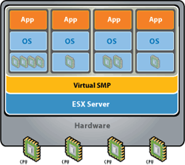

***ESXi***

It is the name of Operating System utilized and built by VMWare. It is also referred as a host sever. A host is a computer that uses virtualization software, such as ESX or ESXi to run virtual machines. Hosts provide the CPU and memory resources that virtual machines use and give virtual machines access to storage and network connectivity. Once installed and configured then you would not be required to have configuration accessed. It will be accessed through vSphere client

ESXi Configuration Screenshot:

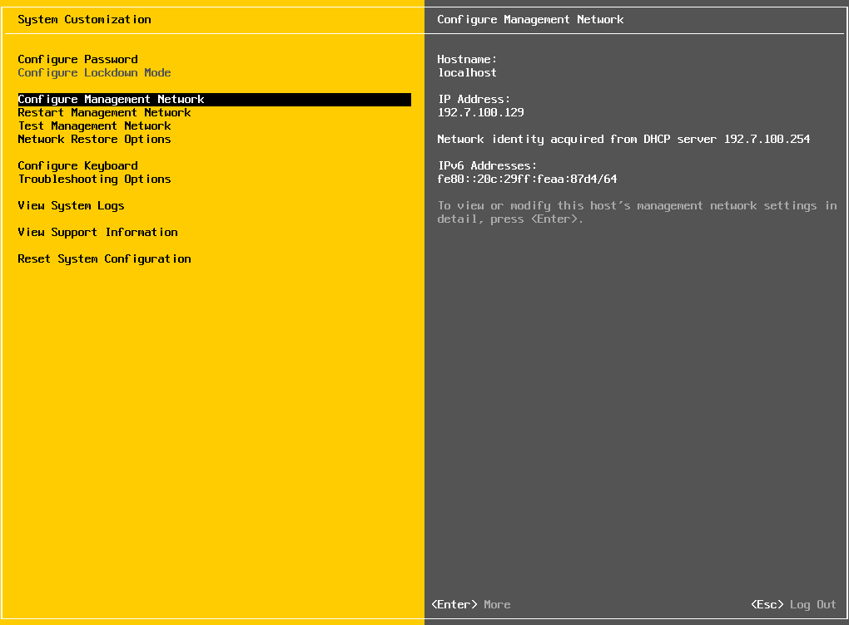

***vSphere***

It is a client which allows you to connect to hosts or vCenter server. It works just like putty or RDP client where you would specify the IP, username and password to login to the host or vCenter server

There are 2 types of vSphere clients, thick and thin client. The thick client has to be installed on the Windows machine where as thin client is a web-based client and can be accessed from any machine running a web browser

vSphere Thick Client Login Screenshot:

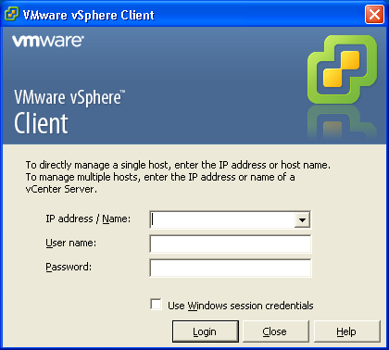

vSphere screenshot after a successful login:

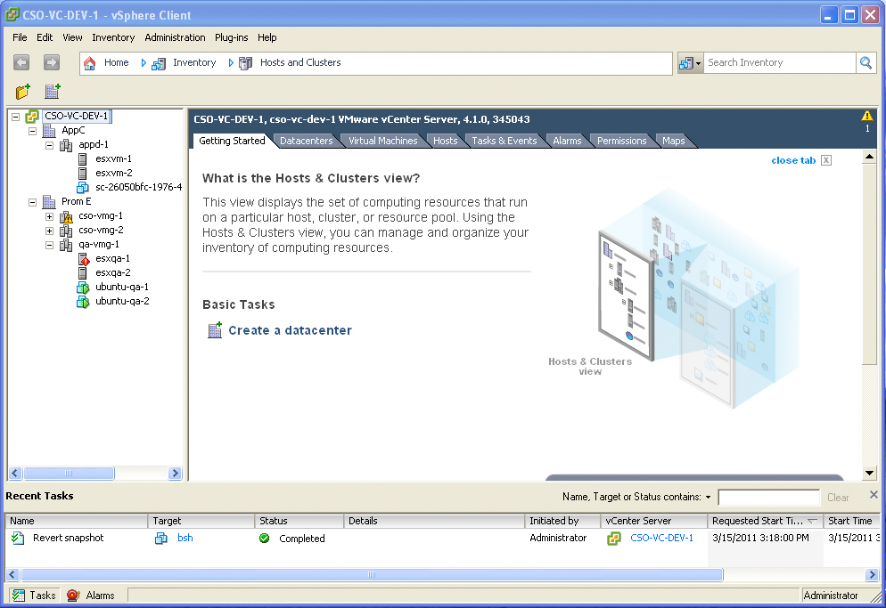

***vCenter***

This VMWare component is used when setting up ESXi hosts in a cluster environment. The vCenter can be accessed the same way as ESXi server through vSphere client. Once the vCenter server is installed and configured then all ESXi servers can be added and a cluster can be configured. There are 2 types of vCenter servers, Windows based and Linux based. For Windows, you would need to install the executable on Windows server. For Linux, you would download the Linux vCenter appliance which will be a Virtual machine itself

vCenter management layout:

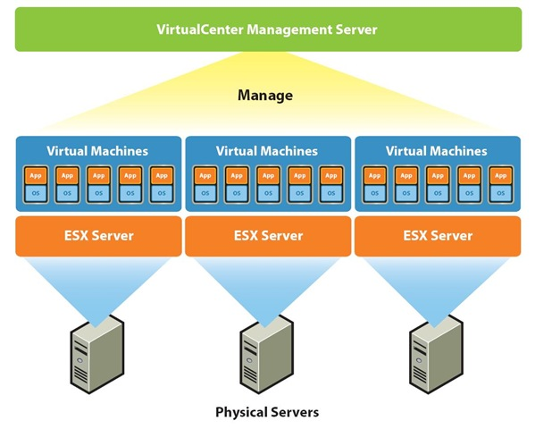

***vCenter Converter***

It allows you to convert physical server to virtual, virtual to virtual and virtual to physical server. This components runs on window environment

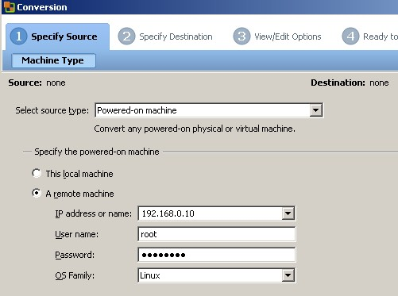

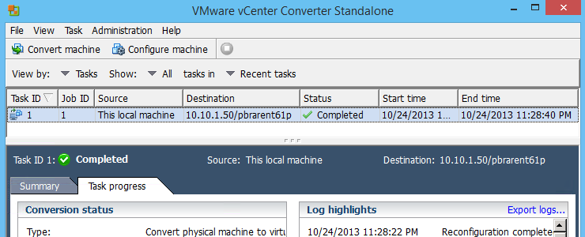

**VMWare Initial Configuration:**

* Install ESXi software on bare-metal hardware.
  + Insert the CD/DVD into the hardware
  + Go to BIOS or hit F8 on your server to boot from the ESXi CD
  + Once the ESXi installation screen appears then simply follow the wizard which is self-explanatory or watch the video on youtube on “ESXi 5.5 installation”

<https://www.youtube.com/watch?v=UVv5K8RItYc>

* + During the installation process, make sure to configure the network, username and password
* Install vSphere client on your Windows laptop or use vSphere web client *(for vCenter)*
  + On your Windows laptop/workstation, install the vSphere thick client and just simply follow the wizard prompt. Make sure the vSphere client has to be the same version as ESXi
  + You can also open up a web-browser and type in the IP address of ESXi server which was configured during the ESXi server installation
  + It will prompt your to HTTPS secure session, click confirm certificate and continue
  + On the “VMware ESXi 5 Welcome” screen you will see one of the following options
    - Download vSphere Client (Follow this link and download the vSphere client)
  + Please note that the web client of vSphere only runs on vCenter server
* Once the vSphere client is installed then double click on the vSphere icon and input IP, username and password of ESXi server which will then bring up the GUI of ESXi/vSphere page

Following the links below to view the installation process:

* VMWare ESXi Installation:

<https://www.youtube.com/watch?v=UVv5K8RItYc>

* VMWare vSphere Client Installation:

<https://www.youtube.com/watch?v=IzYUXwGXk14>

* Setting up new VM on ESXi server

<https://www.youtube.com/watch?v=7ZZAS-7bUs8>